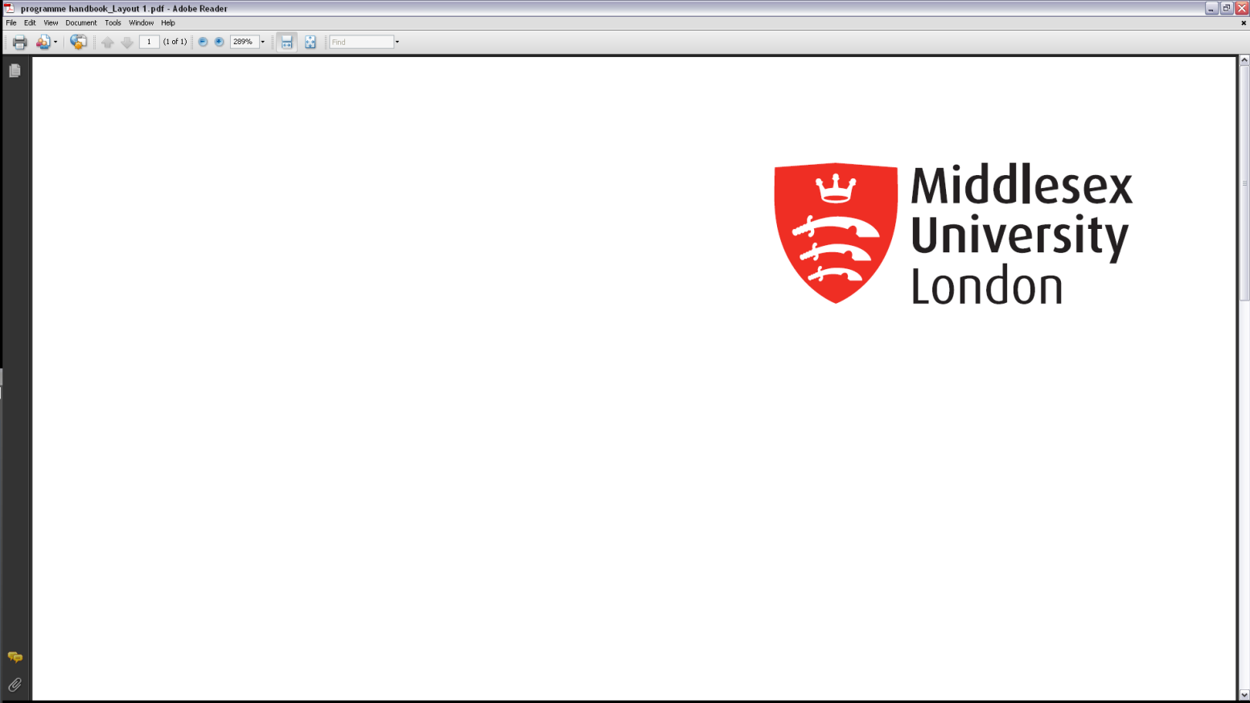

CST2310

Information Systems Analysis and Design

PORTFOLIO of Individual Performance

Submission: Friday 10th February 2023, 23:55hrs (End of Week 17)

Student ID:M00810926

Name: Abdullahi Mohamed

CAMPUS: HENDON

* If you want your work to be marked anonymously then do NOT write your name on the front cover sheet.

**Use Case Diagram: Fitness Centre**

**What is a condition?**

A condition are guarantees that need to be met before proceeding on to the next task to which the post condition must true and executed. (Sparxsystems,2023)

**Reference**

Sparxsytems (2023),Use case diagram tutorial, available from sparx systems at:

[https://sparxsystems.com/resources/tutorials/uml2/use-case-diagram.html#](https://sparxsystems.com/resources/tutorials/uml2/use-case-diagram.html) date accessed 10th February 2023]

**Class Diagram: Case Study Cinema**

**Risk Matrix**

Table 1 Risk Matrix

|  |  |  |  |  |  |
| --- | --- | --- | --- | --- | --- |
| Risk Description | Potential impact on project | Likelihood of occurrence | Difficulty of timely anticipation | Overall threat | Contingency/  Mitigation |
| Poor Communication  (My. UQ, 2022) | high | high | low | high | Clarify anything not understood by peers and allow everyone to voice their opinions.  (My. UQ, 2022) |
| Free Riding  (Eberly Centre, 2022) | low | medium | low | low | Contractional agreement between team members to ensure fairness in the work.  (Eberly Centre, 2022) |
| Isolation of Group Member  (Learning and Teaching, 2022) | medium | high | medium | medium | Review the roles and responsibility of all team members (Learning and Teaching, 2022) |
| Loss of individual Creativity (Library and Services, 2022) | low | high | low | low | Group discussion with explanation (Library and Services, 2022) |
| Personality clashes  (University teaching & learning centre, 2022) | high | medium | medium | high | Allow students to give each other feedback.  (University teaching & learning centre, 2022) |
| Low engagement(Real Business, 2022) | low | medium | low | high | Offer training for communication skills.  (Real Business, 2022) |
| Dominant team members  (Derby, 2022) | medium | high | low | medium | Split the work between every team member.  (Derby, 2022) |
| Lack of physical presence if group work online  (Tyler ,2016) | low | high | medium | low | Select a time a date and set a face-to-face meeting to discuss through progress  (Tyler, 2016) |
| Negativity spurring through the group  (Kent 2019) | medium | high | low | high | Attempt to stay positive at all times for team spirit.  (Kent, 2019) |
| Struggling  (Monash,2022) | high | high | high | high | Seek help from tutor.  (Monash,2022) |

**What risk Management?**

It is the continuing process of identification, evaluating, analysing of a business. It monitors the controls and financial resources to prevent or get over a loss.

**References**

Eberly centre (2022), What are the challenges of group work and how can I address them? Available from: Carnegie Mellon University at: [https://www.cmu.edu/teaching/designteach/teach/instructionalstrategies/groupprojects/challenges.html](https://www.cmu.edu/teaching/designteach/teach/instructionalstrategies/groupprojects/challenges.html%20!%5bdate) ![date accessed:16th December 2022]

my.UQ(2022), Resolving work issues, Available from: university of Queensland at: [https://my.uq.edu.au/information-and-services/student-support/study-skills/group-work/resolving-group-work-issue](https://my.uq.edu.au/information-and-services/student-support/study-skills/group-work/resolving-group-work-issue!%5bdate) ![date accessed:16th December 2022]

Learning and Teaching(2022), Common group challenges and solutions, available from: Iowa state university at: <https://www.celt.iastate.edu/instructional-strategies/effective-teaching-practices/group-work/common-group-work-challenges-and-solutions> ![date accessed:16th December 2022]

Library and Services (2022), Advantages and challenges of group work, available from: Sheridan at:<https://sheridancollege.libguides.com/c.php?g=710256&p=5060349>![date accessed: 16th December 2022]

University teaching & learning centre (2022), Common problems and solution for group work, available from:GW at:

<https://ceils.ucla.edu/wp-content/uploads/sites/2/2016/11/3.4a-Common-Problems-and-Solutions-for-Group-Work.pdf> ![date: accessed: 16th December 2022]

# Real Business (2022), Ten common team challenges and how to overcome them, available from: Prosper Media at

<https://realbusiness.co.uk/ten-common-challenges-that-teams-face-and-how-to-overcome-them> ![date: accessed: 16th December 2022]

Derby (2022), Coping with difficulties in group work, available from: university of Derby at:

<https://libguides.derby.ac.uk/c.php?g=690333&p=4944413> ![date: accessed: 16th December 2022]

Tyler (2016), challenges facing group work online, available from: Tyler Francis Online at:

<https://www.tandfonline.com/doi/full/10.1080/01587919.2016.1154781> ![date accessed 16th December 2022]

Kent (2019), Presentation and group work, available from: University of Kent at:

<https://www.kent.ac.uk/guides/presentations-and-group-work/group-work> ![date accessed 16th December 2022]

Monash (2022), challenges of teamwork, available from: Monash university at:

<https://www.monash.edu/learnhq/collaborate-with-others/collaboration-essentials/challenges-of-teamwork> ![date accessed 16th December 2022]

Marquette (2023), what is risk management available from Marquette at:

[https://www.marquette.edu/riskunit/riskmanagement/whatis](https://www.marquette.edu/riskunit/riskmanagement/whatis.shtml#:~:text=Overview,of%20claims%20and%20liability%20judgments) date accessed 10th February 2023]

## **Diagram Description automatically generatedDiagram Description automatically generatedActivity Diagram: CSSC**

## **What is a swim lane and a pin in an activity diagram?**

## **Swim lanes** are horizontal or vertical lanes in an activity diagram that are used to organise and categorise activities depending on the participant's role or responsibility. Each swim lane in an activity diagram symbolises a distinct role or participant in the process. (GeekforGeeks,2023)

A **pin** is an object node that handles action inputs and outputs. The pin is typically shown as a little rectangle connected to the action rectangle. The pin's name might be shown beside the pin. (UML Diagrams,2012)

**References**

GeekforGeeks (2022), Swim lanes in an Activity diagram, available from GG at:

<https://www.geeksforgeeks.org/swim-lanes-in-activity-diagram/> date accessed 24th January 2023]

UML Diagrams (2012), what are pins nodes, available from object nodes at:

<https://www.uml-diagrams.org/activity-diagrams-objects.html> ![date accessed 24th January 2023]

**Sequence Diagram: CSSC**

**LOOP**



A Sequence Frame Notation is a graphical notation that is used in a UML Sequence Diagram to establish a border around all messages and lifelines in a communication sequence. A Sequence Frame Notation is represented as a huge rectangle with a pentagon in the upper left corner. (Visuals Paradigm,2023)

Visual Paradigm (2023), What are frames?, available from: Visuals Paradigm at:

<https://www.visual-paradigm.com/guide/sysml/modeling-scenarios-with-sequence-diagram/#:~:text=A%20Sequence%20Frame%20Notation%20is,at%20the%20top%20left%20corner> ![date accessed 8th February 2023]